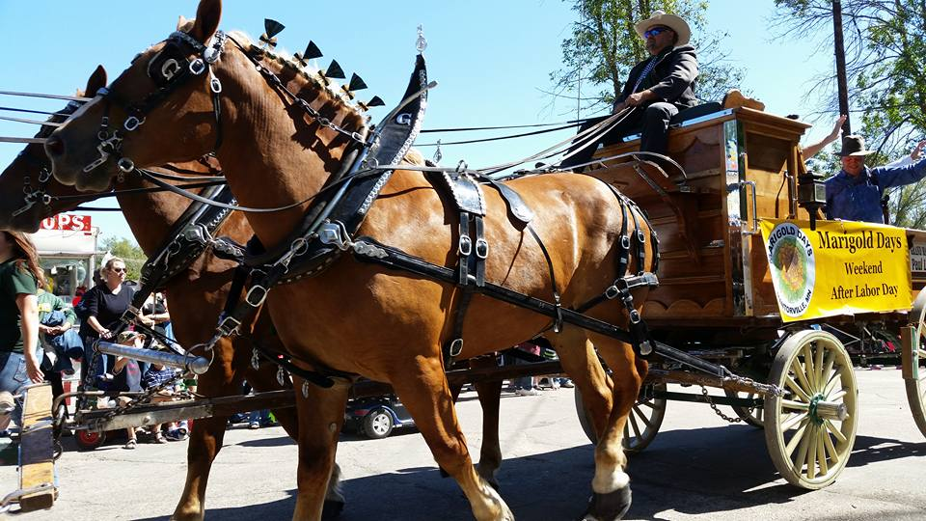

Parade Information and Registration Form

The Mantorville Restoration Association is proud to announce
the 55th Annual Celebration of Marigold Days,
which will be held September 12 & 13, 2020
We are once again planning to feature our Grande Parade on Sunday, September 13th,
at 1:30 pm. If you or your organization is interested in entering our Grande Parade, please fill out the registration questions below or reply to this email by August 1st. On or about September 1st, you will receive an email confirming your attendance, line-up information and your parade unit number.
COMMERCIAL/ADVERTISING ENTRIES: Because of the costs involved in making our Parade successful, a required donation of $25 is requested for all commercial entries. This helps offset some of the advertising and clerical costs involved in presenting the Parade. (Organizations and clubs in Mantorville and Kasson are exempt from the donation).
Please make checks payable to:
Mantorville Restoration Association (MRA)
and mail to:
Marigold Day Parade Chair; Nancy Tobiason
P.O. Box 281
Mantorville, MN 55955

The route is approximately 1 mile long. All units must be self-insured.

If you have questions, please contact Nancy Tobiason at 507-635-5799, or by email: namitchell@hotmail.com
Parade will be held rain or shine. We hope you can join us!
Nancy Tobiason, Parade Chairperson

Parade Registration/Entry Questions
Entry Name/Organization:

Brief Description of your unit (include type - float/motorized vehicle type/walking/animals):

Total length of unit:

Approximate number of participants:

Is your unit Musical?

Entry Contact Name:

Address:

Telephone:

Email Address:
Please make checks payable to:
Mantorville Restoration Association (MRA)
and mail to:
Marigold Day Parade Chair; Nancy Tobiason
P.O. Box 281
Mantorville, MN 55955

Thank you!

